Little Birch Parish council
Ward member report, July 2016

TRO update
I recently attended a BBLP update at which they talked about the possibility of giving more power to Parish councils with regard to ‘sponsoring’ TROs to speed them up. See below, more detail to follow as & when released.
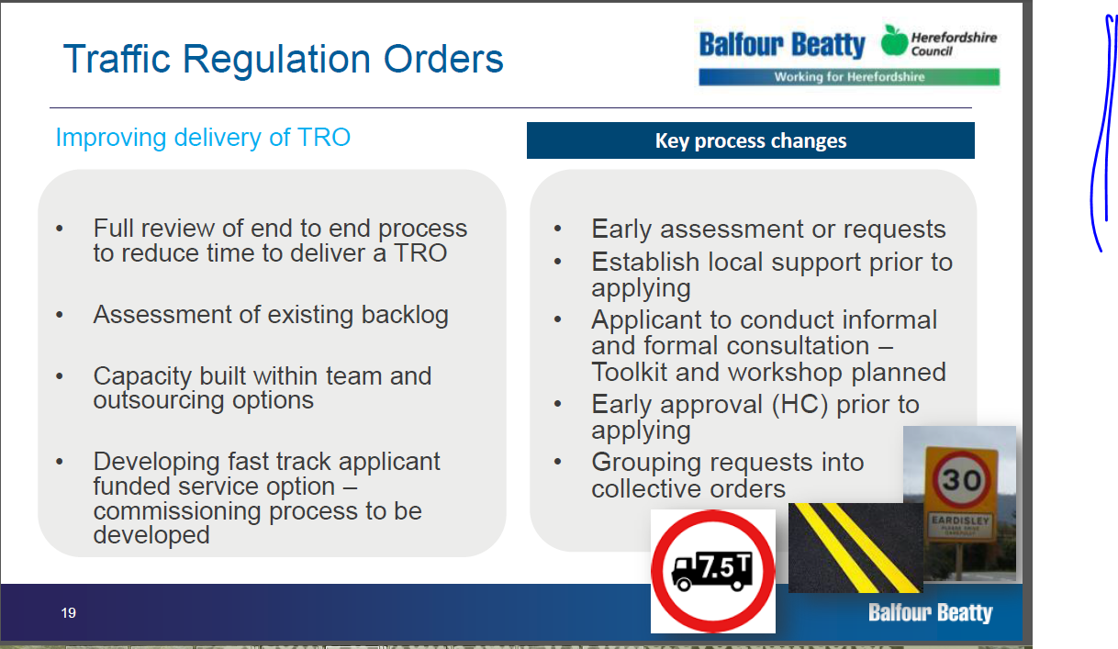

Bus services
The council will be undertaking a further public consultation this summer on the county’s bus services. Details will shortly appear on the council’s website.
The background is that 39% of the 3.1 million journeys undertaken last year were subsidised at a cost of £1.3M. On top of this there is the cost of reimbursing private bus operators the ‘free fares’ for the concessionary travel offered by bus passes for the elderly and disabled; this is a further £1.4M. In the context of disappearing central government grants these figures are material.
The routes in this area most likely to come under pressure are 412/413 Garway – King’s Thorn – Hereford. Services are likely to come under pressure if they are not better supported.

Dobbin’s cottage
I have met with Elaine Godding and Charles Jones from the County surveying department with a view to helping Ms Rooke who lives next to Dobbin’s cottage. We now have the Environmental Health department involved and hope to see some action this month. Elaine will give an update on the situation.

Little Birch village Hall bin collection
Following an enquiry from Mike Morley about waste collection at the village hall I have received the following response:
The services we provide to village halls differs from other non-households in that we currently provide up to 2 x 240 litre green recycling bins collected fortnightly free of charge. All other waste from a village hall is considered as commercial waste and charged accordingly through our trade waste service. This is not a change in service or a new rule and bin crews have never been authorised to collect black sacks/bins from village halls.

City of culture bid
A group of Herefordians led by the Courtyard’s Roger Morgan are putting together a bid for Hereford to become the UK’s city of culture in 2021. Unlike many of the other bids, our bid will effectively be a ‘county of culture’ bid and will be organised and submitted entirely by a group of enthusiasts passionate about Herefordshire.
According to the group: ‘Herefordshire has a significant net outflow of young adults who leave the county each year. Research shows that young people leave the county for education and alternative employment opportunities due to the relatively low paid and low skilled jobs available locally, but also because of a perceived lack of wider social and cultural activities…..Bidding for the City of Culture will play a major part in the overall positioning of the county as a place to live, work, play, study and visit. The City of Culture would provide Herefordshire with a strong and influential brand which would support local enterprise and inward investment.’
If anyone wishes to volunteer for the bid team then please contact Roger at the Courtyard, Hereford.

